
JENESYS2025 Cambodia-Japan Young Politics-oriented Exchange
(Invitation Program) Report

1. Program Overview
【Objectives and Overview】
This program was implemented from March 17 to 24 with the aim of deepening the understanding of ten young Cambodian political leaders—who are expected to play key roles in the country’s future—regarding Japan’s democratic system, as well as providing opportunities to learn about Japan’s experiences with multiparty democracy, judicial and electoral systems, and related fields. Through these activities, the program sought to offer perspectives that may support their future engagement and contribute to peace and stability in the region.

【Participants】Total: 10 politics-oriented youths from Cambodia

【Locations】Tokyo 10, Kanagawa 10

【Schedule】
- Online Pre-study Program:
Mar. 10 (Tue) 【Pre-departure Orientation】
Set Period Prior to Arrival 【Task-based Learning (VOD)】“Overview/Mission”, “Message from Minamisanriku”, “Allure Aichi -Industry / Cutting-edge technology –”, “Study Japanese Culture in Kyoto”, “Peace Tour in Hiroshima”

- Invitation Program:
Mar. 17 (Tue) Arrival at Narita International Airport
【Post-arrival Orientation】
【Observation】LEAF FACTORY TOKYO CO., Ltd.
Mar. 18 (Wed) 【Observation of a Theme Related Facility/Organization】
Tour of the National Diet Building, Overview of Japan’s parliamentary system by
the Secretariat of the House of Representatives
【Courtesy Call】Ms. KUNIMITSU Ayano, State Minister for Foreign Affairs
【Observation】Imperial Palace, Nijubashi Double Bridge
【Opinion Exchange】Japan-Cambodia Parliamentary Friendship League
Mar. 19 (Thu) 【Theme Related Observation】
Tokyo Metropolitan Secretariat to Election Administration Commission
【Theme Related Lecture】“About Democracy”
Lecturer: Dr. TANIGUCHI Tomohiko, Specially Appointed Professor, University
of Tsukuba
Mar. 20 (Fri) 【Cultural Experience, Observation】Tea Ceremony Experience, Asakusa
【Observation】The Seiko Museum Ginza
【Observation】Tokyo Tower
Mar. 21 (Sat) Travel from Tokyo to Kanagawa
【Cultural Experience, Observation】Japan Open-Air Folk House Museum,
Traditional Indigo Dyeing Experience
【Observation】Yokohama Bay Bridge Skywalk
【Observation】Enoshima
Mar. 22 (Sun) 【Observation】Tsurugaoka Hachimangu, Kotoku-in Temple
【Observation】Hase-dera Temple, Kamakura Komachi Street
【Theme Related Observation】
Polling Station and Vote-Counting Center for the Zushi City Council Election
Mer. 23 (Mon) 【Observation】The Matsushita Institute of Government and Management
Travel from Kanagawa to Tokyo
【Reporting Session】
【Opinion Exchange with Theme Related Officials】Dinner Meeting, hosted by
Mr. SHIMADA Tomoaki, Parliamentary Vice-Minister for Foreign Affairs
Mar. 24 (Tue) Departure from Narita International Airport

2. Program Photos
Invitation Program
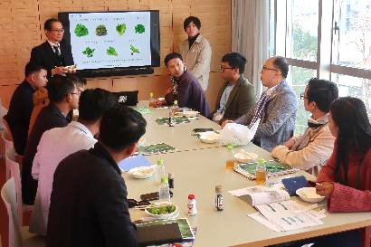 | 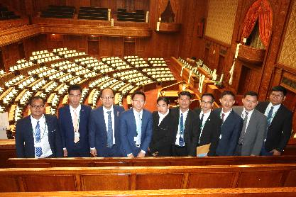
March 17, 2026【Observation】  LEAF FACTORY TOKYO CO., Ltd. | March 18, 2026【Observation of a Theme Related Facility/Organization】National Diet Building
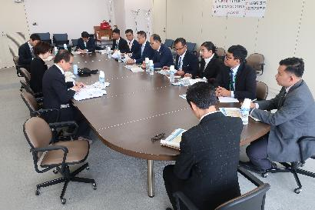 | 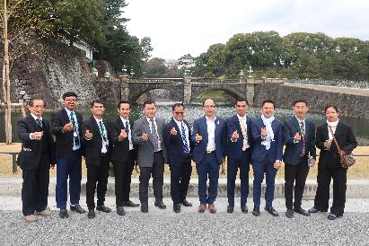
March 18, 2026【Observation of a Theme Related Facility/Organization】Overview of Japan’s parliamentary system by the Secretariat of the House of Representatives | March 18, 2026【Observation】Imperial Palace, Nijubashi Double Bridge
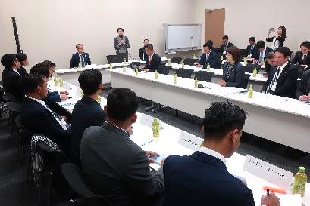 | 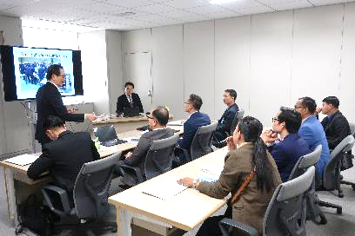
March 18, 2026【Opinion Exchange】Japan-Cambodia Parliamentary Friendship League | March 19, 2026【Theme Related Observation】  Tokyo Metropolitan Secretariat to Election Administration Commission
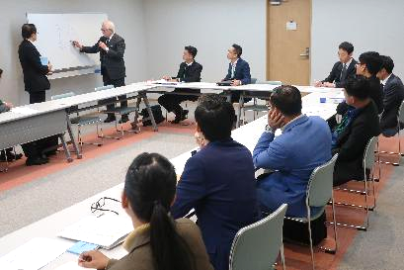 | 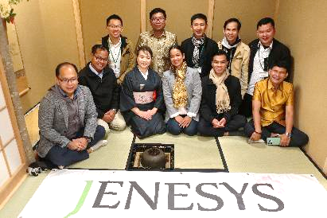
March 19, 2026【Theme Related Lecture】  “About Democracy” | March 20, 2026【Cultural Experience】  Tea Ceremony Experience
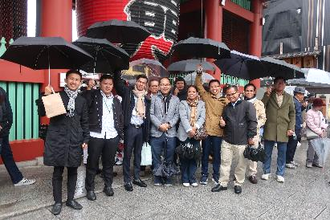 | 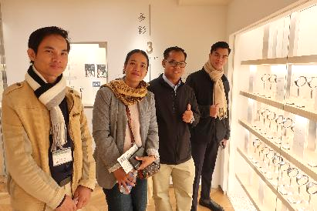
March 20, 2026【Observation】  Asakusa | March 20, 2026【Observation】  The Seiko Museum Ginza
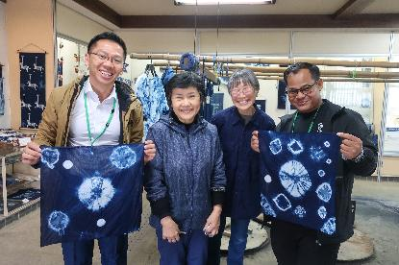 | 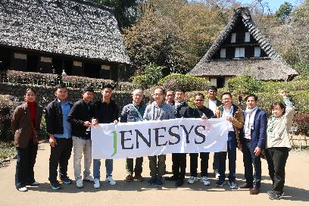
March 21, 2026【Cultural Experience, Observation】Traditional Indigo Dyeing Experience | March 21, 2026【Cultural Experience, Observation】Japan Open- Air Folk House Museum
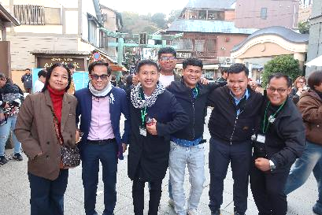 | 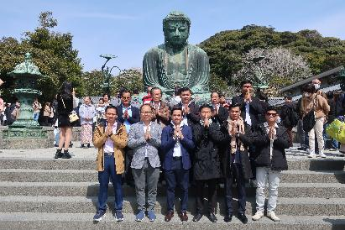
March 21, 2026【Observation】Enoshima | March 22, 2026【Observation】Kotoku-in Temple
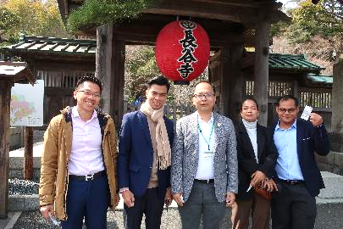 | 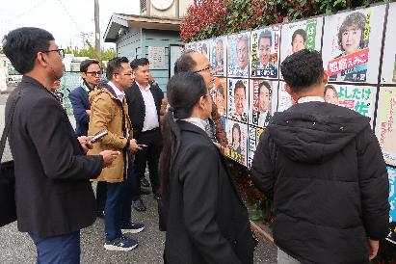
March 22, 2026【Observation】  Hase-dera Temple | March 22, 2026【Theme Related Observation】  Zushi City Council Election
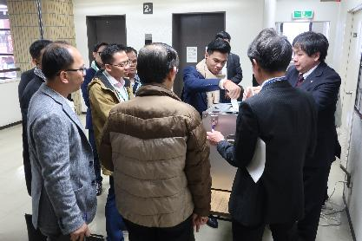 | 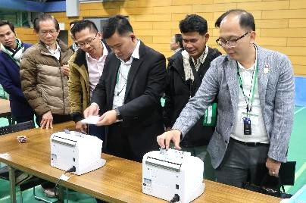
March 22, 2026【Theme Related Observation】  Polling Station | March 22, 2026【Theme Related Observation】  Vote-Counting Center
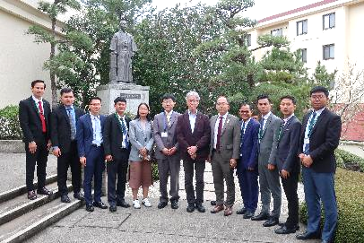 | 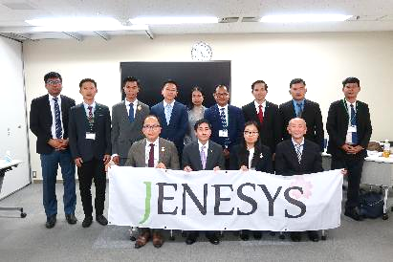
March 23, 2026【Observation】The Matsushita Institute of Government and Management | March 23, 2026【Reporting Session】

3. Voices from the Participants (excerpt)
- Working Youth
We were able to learn about Japan’s socio-economic development. The program highlighted the importance of respect for the rule of law, the maintenance of public order, and citizen participation in national development. In addition, the insights gained from Japan’s experience in modern agriculture and technology provided new perspectives for Cambodia’s own development.
- Working Youth
For young people, particularly emerging political actors, this program provided an opportunity to get to know one another and deepen their knowledge. In particular, they were able to learn about a philosophy of peace that emphasizes living together under one nation, respecting one another, engaging in competition only in terms of ideas and leadership styles, and refraining from viewing others as adversaries—an approach grounded in a culture of dialogue. This philosophy aligns well with the vision and position of our party.
- Working Youth
What left the strongest impression on me was the tea ceremony. Conducted in a meditative atmosphere, the tea ceremony can truly be said to reflect an aspect of samurai culture. In this small tearoom, there are no swords, no allies or enemies—only the quiet preparation of matcha and the enjoyment of a moment of stillness. For young politicians from diverse backgrounds, this experience may serve as a catalyst for applying the spirit and practice of the tea ceremony to the political arena.

4. Voices from the Receiving Parties (excerpt)
- Observation Destination Representative
It was highly meaningful for us as well that the participants showed interest in our work and that we were able to exchange a wide range of views during our interactions. We also learned that, in some countries, plant factories are not yet widely known. This realization reinforced a sense of motivation and pride among our staff, as it highlighted the value of operating an agricultural business that utilizes cutting-edge technologies.
- Observation Destination Representative
The enthusiasm of all participants was evident throughout the entire program—from the overview briefing to the facility tour, and at every location and moment.

5. Disseminations by the Participants (excerpt), Articles, etc.
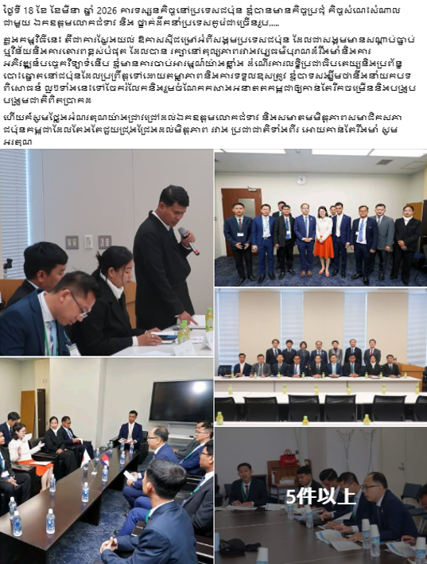 | 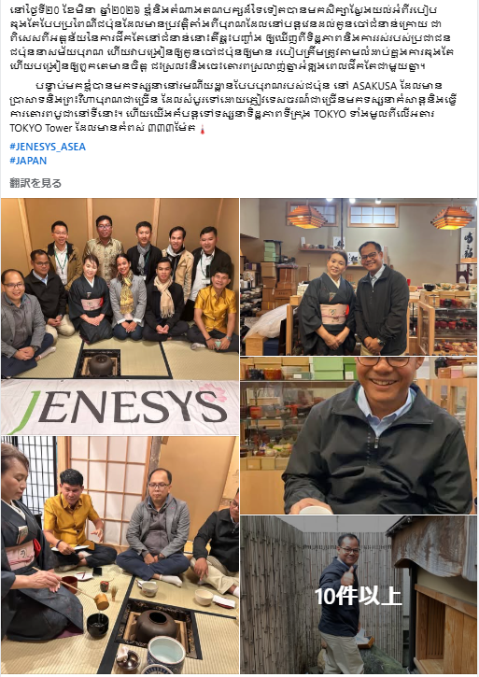
March 19, 2026 (Facebook)  Working Youth  During my visit to Japan, I had the opportunity to meet and exchange views with the Vice Minister for Foreign Affairs, as well as with many other Japanese leaders. This experience allowed me to gain a deeper understanding of Japanese society, which places strong emphasis on discipline and mutual respect while maintaining a thoughtful balance between its rich traditional culture and advanced technological development.  I became particularly interested in how democracy is practiced in Japan, including its highly transparent and accountable electoral system. I sincerely hope to share these valuable experiences upon my return and to contribute to Cambodia’s future development and the realization of genuine national unity. | March 21, 2026 (Facebook)  Working Youth  Together with representatives from other political parties, I had the opportunity to learn about the traditional Japanese tea ceremony, which has been passed down through generations for centuries. I came to understand that the act of drinking tea itself deeply reflects the daily lives, values, and social ethos of the Japanese people.  Through learning the proper movements and sequence involved in preparing and serving tea, I was deeply impressed by how discipline and etiquette have long been taught to Japanese children. Moreover, I learned that the shared experience of enjoying tea together has fostered a spirit of openness, mutual respect, and consideration for others.  Following this experience, I visited Asakusa, one of Japan’s most traditional and historic tourist areas. The district is home to many ancient temples and shrines, and I observed numerous visitors from both Japan and abroad enjoying worship and sightseeing. In addition, I was fortunate to have the opportunity to ascend Tokyo Tower, which stands at a height of 333 meters, and to take in a panoramic view of the city of Tokyo.
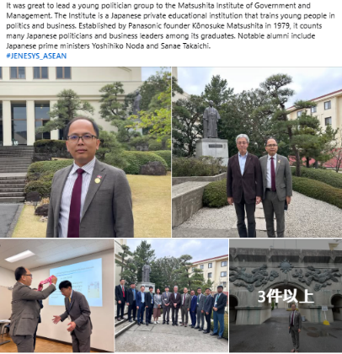 | 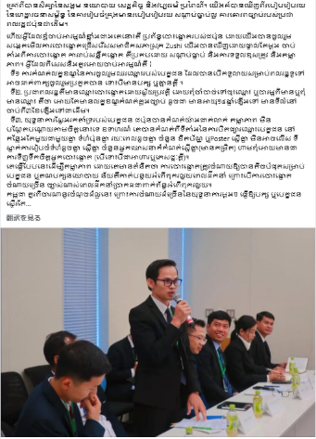
March 23, 2026 (Facebook)  Working Youth  It was great to lead a young politician group to the Matsushita Institute of Government and Management. The Institute is a Japanese private educational institution that trains young people in politics and business. Established by Panasonic founder Kōnosuke Matsushita in 1979, it counts many Japanese politicians and business leaders among its graduates. Notable alumni include Japanese prime ministers Yoshihiko Noda and Sanae Takaichi. | March 27, 2026 (Facebook)  Working Youth  In addition to learning about society, politics, the economy, and traditional culture, we were able to directly observe the way infrastructure development is carried out in Japan, how urban planning is implemented in an orderly and systematic manner, and the high level of legal compliance among the Japanese people.  Among these experiences, the aspect that drew my strongest interest was Japan’s electoral system. We had the opportunity to observe firsthand the voting and vote-counting processes of a local assembly election in Zushi City, Kanagawa Prefecture. From the casting of ballots to the counting of votes, every stage of the process was conducted in an orderly manner, with a strong sense of responsibility and a high degree of transparency, which we were able to confirm directly on site.  In particular, the following points were especially impressive and worthy of attention. First is the eligibility to run for office. In Japan, the conditions for candidacy are broadly inclusive. Regardless of whether one belongs to a political party, any ordinary citizen who meets the prescribed requirements is eligible to stand as a candidate.  Second is the voter registration system. In Japan, voters are automatically registered on the electoral roll, eliminating the need for individuals to apply separately or worry about their registration status. As long as the legal requirements—such as being 18 years of age or older and having resided in the relevant area for a specified period (for example, three months or more)—are met, voting eligibility is granted.  Third is the strict regulation of election campaigning. In Japan, campaign activities are clearly defined and rigorously regulated in a transparent manner. For example, posters displaying candidates’ names are placed together in designated locations, with uniform size, identical display periods, and strict limits on the number of posters and flyers permitted. Similar restrictions apply to the size of campaign offices and the number of campaign staff. In addition, any form of providing benefits to voters, including food and beverages, is strictly prohibited.  These systems are designed to ensure the transparency of elections and are based on the principle of minimizing election-related costs for candidates and political parties. Excessive campaign spending increases the risk of corruption in post-election political governance. For this reason, I believe that Cambodia should also draw lessons from these commendable practices. Excessive expenditure on election campaigns can place a heavy burden on political parties and candidates and may give rise to various challenges within society.
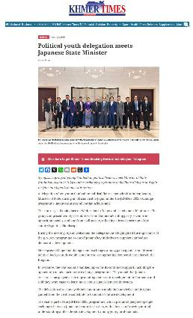 | 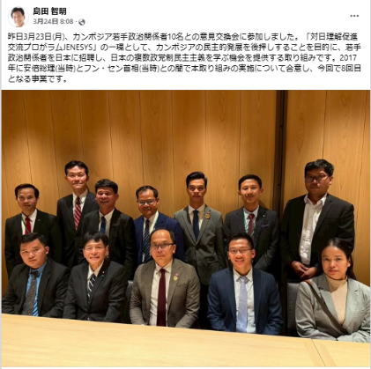
March 20, 2026 (Khmer Times)  “Young Cambodian political figures met with Ms. KUNIMITSU Ayano, Vice Minister for Foreign Affairs, in Tokyo as part of an exchange program aimed at promoting dialogue and deepening their understanding of Japan’s democratic system.” | March 24, 2026 (Mr. SHIMADA Tomoaki’s Facebook, Parliamentary Vice-Minister for Foreign Affairs)  “I participated in a discussion meeting with ten young Cambodian political figures.”
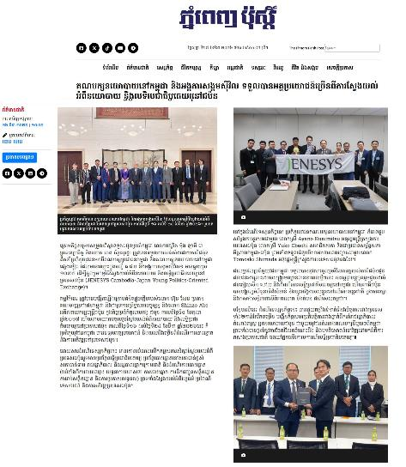 | 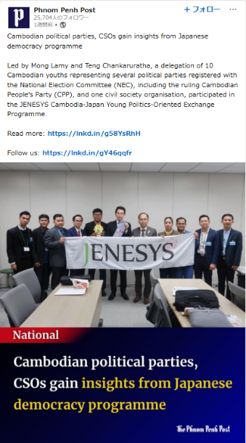
March 26, 2026 (Post Khmer)  “Cambodian political parties and civil society organizations were able to gain many valuable insights by deepening their understanding of Japan’s politics and democracy. ” | March 26, 2026 (The Phnom Penh Post’s LinkedIn)  Ten young Cambodian participants representing political parties registered with the National Election Committee (NEC), including the ruling Cambodian People’s Party, as well as representatives of civil society organizations, took part in the “JENESYS Cambodia–Japan Young Political Leaders Exchange Program.”
6. Presentations of Program Findings at the Reporting Session (excerpt)
- I aspire to contribute to Cambodia’s development and the advancement of democracy through leadership development. Our political party upholds the principle of balance between cause and effect and is guided by a strong commitment to protecting socially vulnerable groups. I have learned that meaningful national change often begins with small groups of dedicated individuals, and that the accumulation of such efforts can ultimately transform society.
During Dr. Taniguchi’s lecture, one statement left a particularly strong impression on me: “If there are 50 people with firm and well‑grounded convictions, democracy can develop.” For example, the Matsushita Institute of Government and Management has produced only around 300 graduates, yet many have gone on to become leaders who exert significant influence on society. This made me realize that meaningful change is indeed possible even with a relatively small number of people.
In Japanese society, a deeply rooted culture of mutual respect is evident—not only in traditional practices such as the tea ceremony, but also in various public settings, including polling stations. Inspired by this, I am committed to valuing an inclusive and respectful approach in my own political activities. Together with my colleagues, I hope to contribute to peace in Cambodia and in the wider world.
- Through the week-long study visit, I was able to deepen my understanding of Japanese daily life and cultural values. I was particularly impressed by Japan’s ability to consciously preserve its rich traditional culture while simultaneously achieving remarkable technological and economic development.
During this program, we had the opportunity to visit the National Diet, pay a courtesy call on the Vice Minister for Foreign Affairs, and learn extensively about Japanese democracy. Japan generously shared its knowledge and experiences not only with us, but also with young people from Pacific nations such as ourselves, emphasizing the importance of democracy and equality.
Dr. Taniguchi’s lecture, in particular, taught us that development must be pursued with a sense of hope—for oneself and for one’s country. Furthermore, through the tea ceremony experience, I learned the importance of mutual respect and treating all individuals equally, regardless of status or background. I felt that these values form a fundamental philosophical foundation for Japanese political leaders.
I hope to share the knowledge and insights gained through this program with young people in Cambodia who aspire to pursue careers in politics.
- During my time in Japan, I had the opportunity to learn about three key areas. The first was Japanese culture, including the tea ceremony, Japanese society, and democracy. Through the lectures at the Matsushita Institute of Government and Management, I was able to truly feel how deeply these values are rooted in Japanese society. This was an extremely valuable experience for me personally, and I also believe that Japan serves as a positive model for Cambodia.
The second area was Japan’s parliamentary system. I was particularly impressed by the fact that even if a member of parliament is expelled from their political party, their status as a legislator is not revoked. In Japan, legislators are guaranteed their position even when they hold views that differ from their party’s policies. I believe this represents a fundamental principle of freedom of expression and forms the very basis of democracy.
The third area was the process of voting and vote counting. During the vote-counting process, various technologies are employed to ensure transparency. We were able to observe vote-counting procedures that utilize new technologies unfamiliar to us, allowing us to gain knowledge that will be beneficial to Cambodian society.
- Through the JENESYS Program, young political figures from Cambodia were given the opportunity to study and learn about Japanese democracy. Among the eight-day program, the experience that left the strongest impression on me was observing the Zushi City Council election, where transparency was ensured throughout the entire process.
By learning from Japan’s practices, I hope to contribute to improving Cambodia’s electoral system. In addition, I intend to share the principles of democracy and the sense of discipline embedded in Japanese society within my political party and across Cambodian society.
Moving forward, I am committed to working toward the unity and peace of the Cambodian people, while also striving to sustain and further strengthen the friendly relationship between Japan and Cambodia.
- Despite belonging to different political parties and holding differing political ideologies, we were able to cultivate friendship here in Japan. The Government of Japan has long contributed to peacebuilding efforts in Cambodia and supported the constitutional drafting process in 1993. Through this program, I also came to realize that there are many similarities between the electoral systems of Cambodia and Japan.
In Professor Taniguchi’s lecture, I learned that although democracy originated in the Western world, Japan has not simply imitated Western models. Instead, it has refined and developed its own form of democracy in a manner suited to its society and culture. I was also deeply impressed by the lesson that national leaders must genuinely love their country and their people.
Under the leadership of the current Prime Minister, I hope to work toward further developing democracy in Cambodia and creating an environment in which diverse political parties are able to participate actively in political life.

Implementation Agency: Japan International Cooperation Center (JICE)

